Tool:

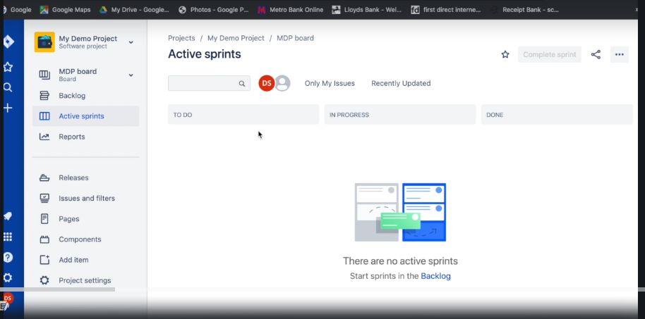

Creating first user story:

Got to backlog > create a story add description, label, story point (number of story)

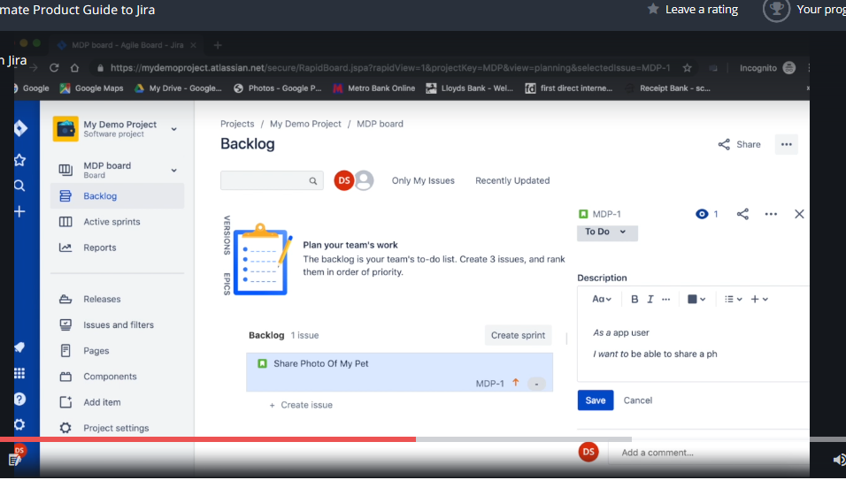

Prioritization of the task from the back log

Move the items up and down to move the priority

Create sprint using button on the top

Enter the sprint information.

Drag and drop the items to the spritn

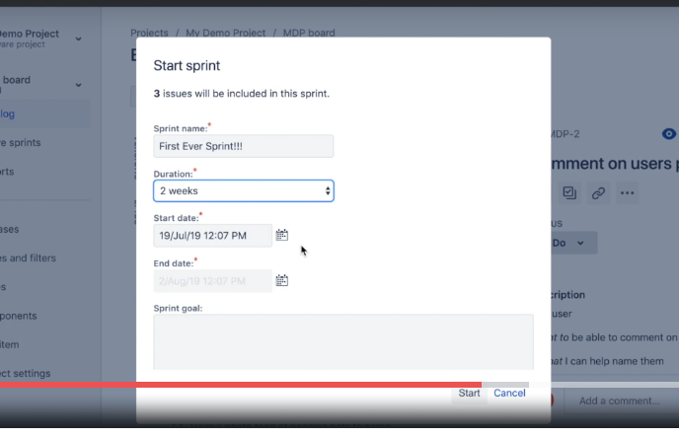

Drag drop

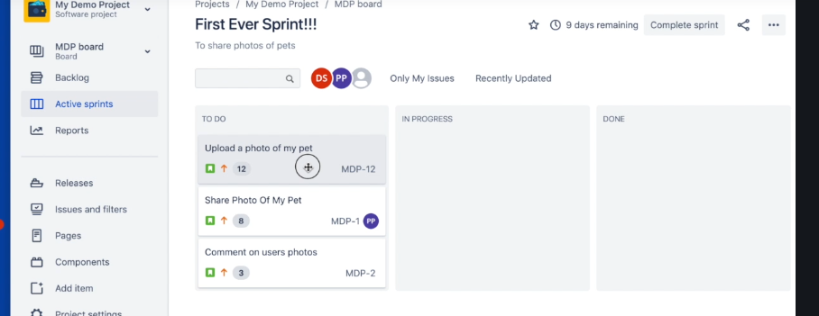

EPICS:

Logical related stuff are grouped under a epic

Big feature is divided into multiple task and then grouped together under single label called Epic

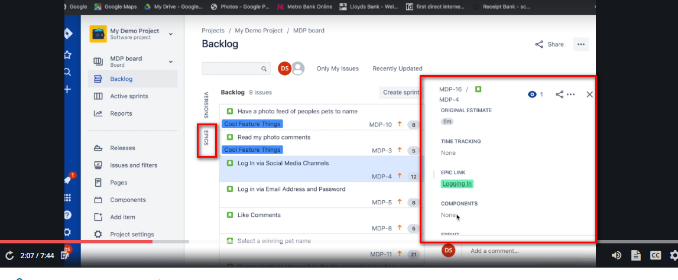

Also we have progress indicators

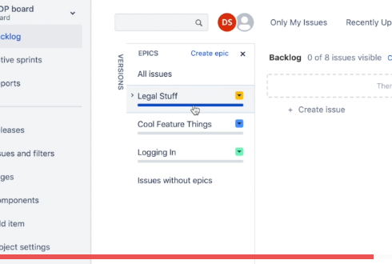

Click on epic will display all the linked tasks/stories.

When completed mark it as done.

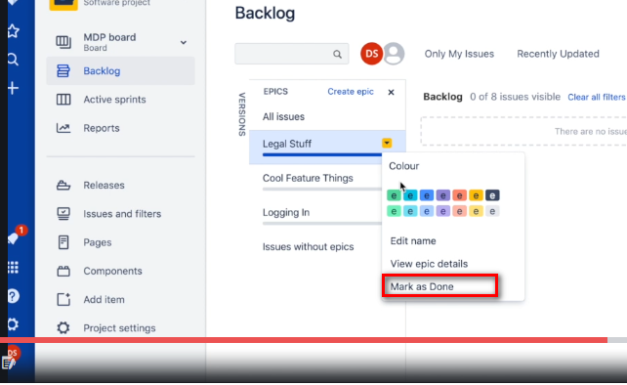

Acceptance criteria:

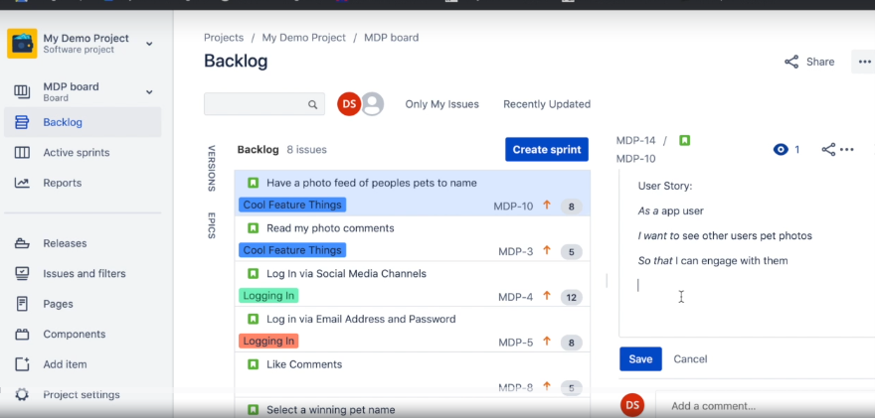

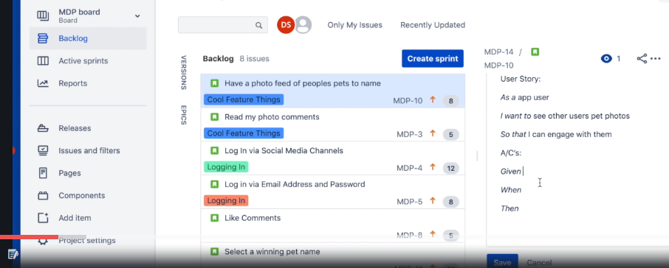

ON the task level it can be linked to another task which is blocking the current task.,

Jira admin:

1.Settings > user management

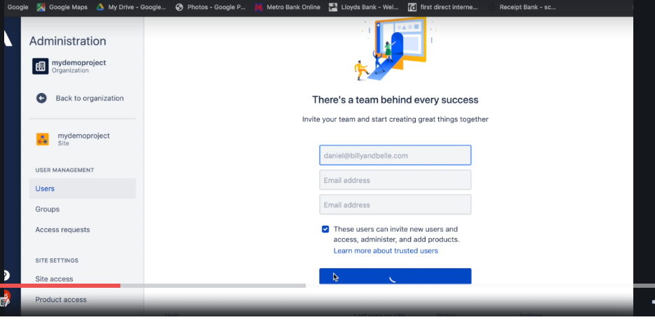

Add email and invite team member

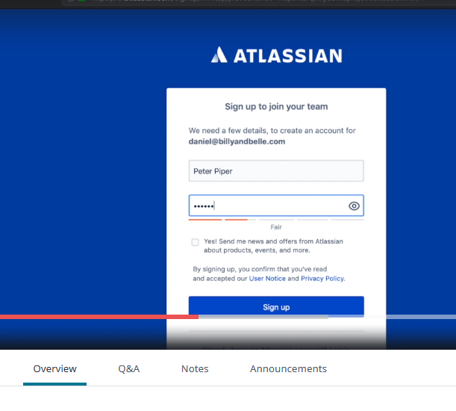

Click on to link sent via email and join the team with company credential preferably

Sprint board and columns:

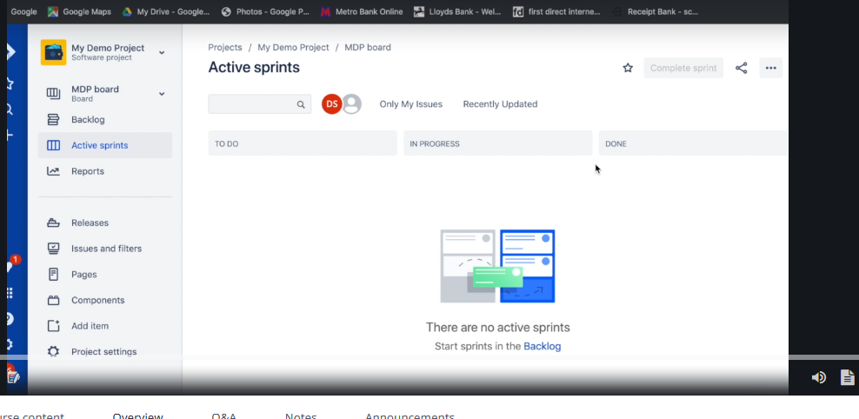



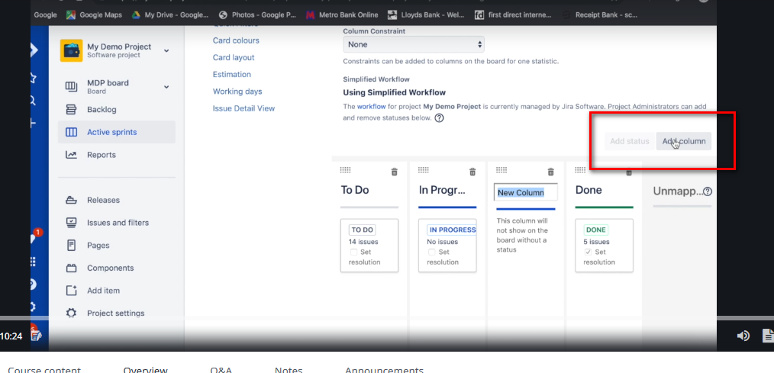

Setting:

Creating new type fort he work(bugs, task, sub task, epic)

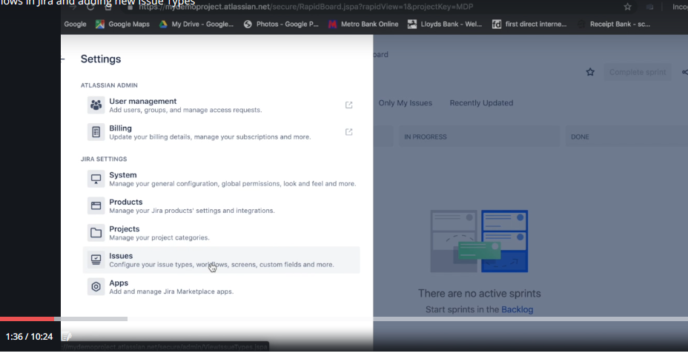

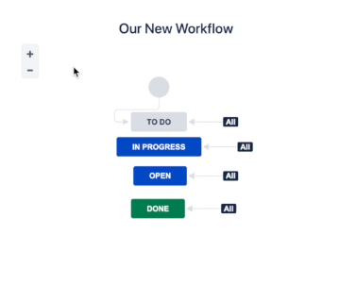

To add new column we need to have new work flow to it so that we can assign new status to it

Settings >> Issues >> work flows >>

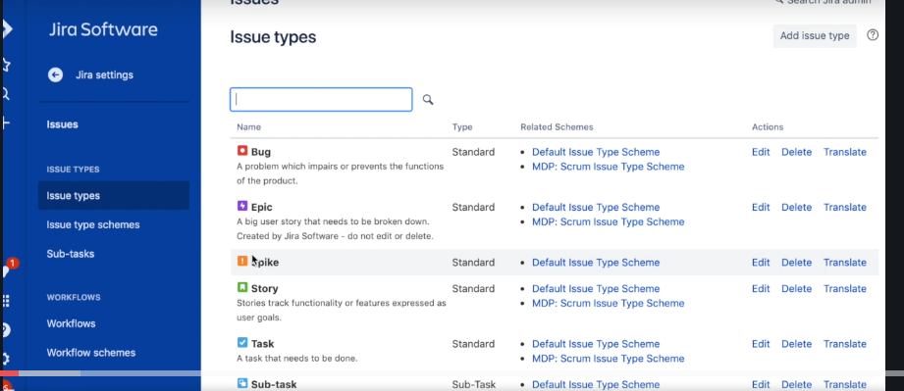

Tool used for the project management and bug tracking.

Handling issue, bugs, functionality over mail with distributed team is very difficult to keep track of all emails

So we need a centralized tool where in everything about the bug or feature is available accessed by all the team members.

Say few task assigned to me in the beginning which is evolve over a period of time it difficult to track this changes with excel work notepad

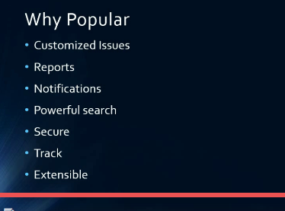

Open source licensed software

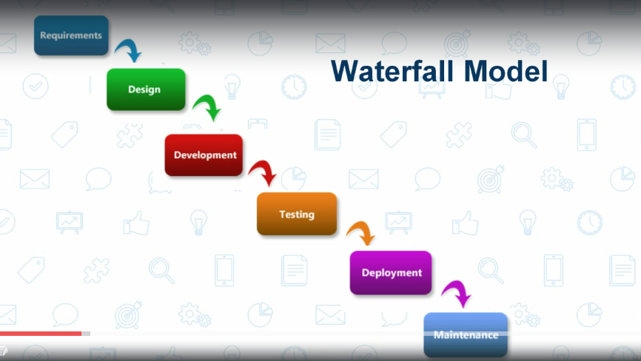

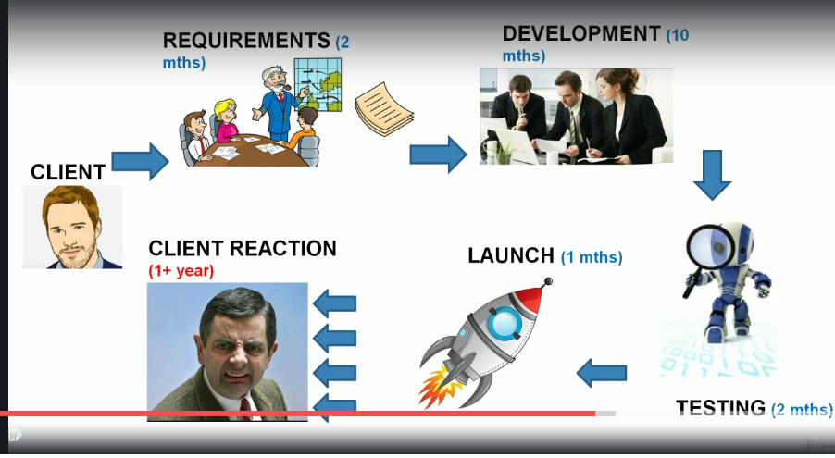

What is not agile:

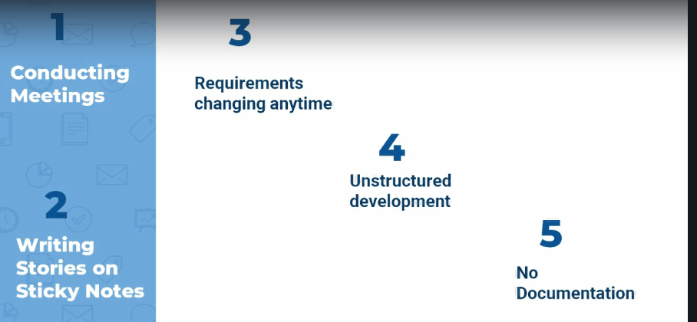

Set of believes to be followed to for the best outcome.

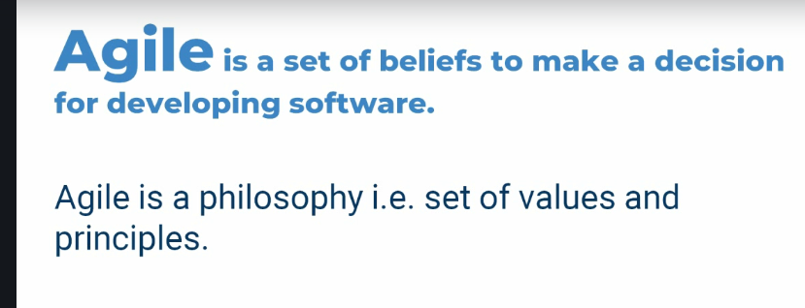

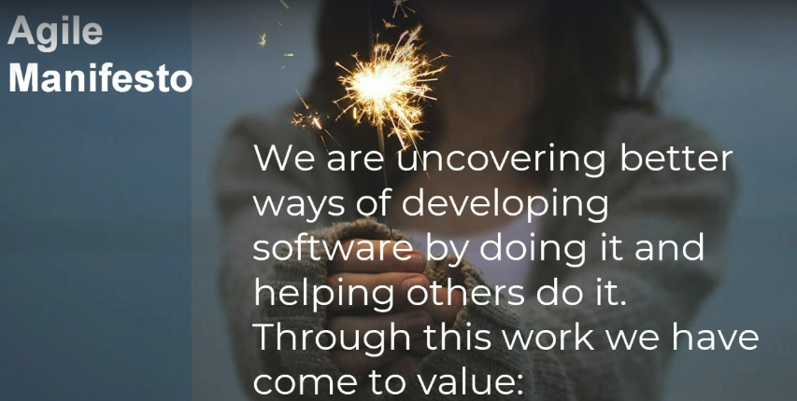

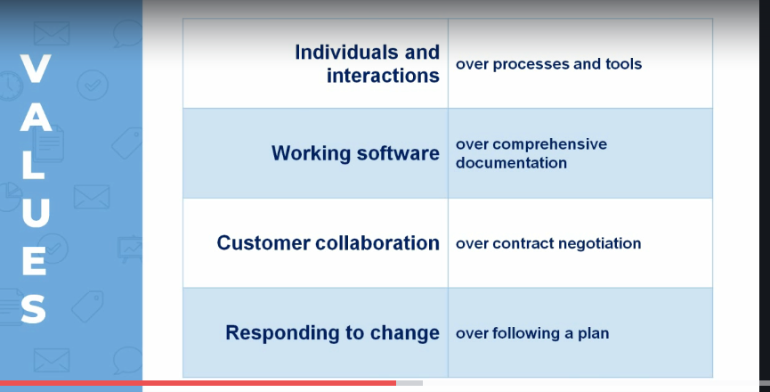

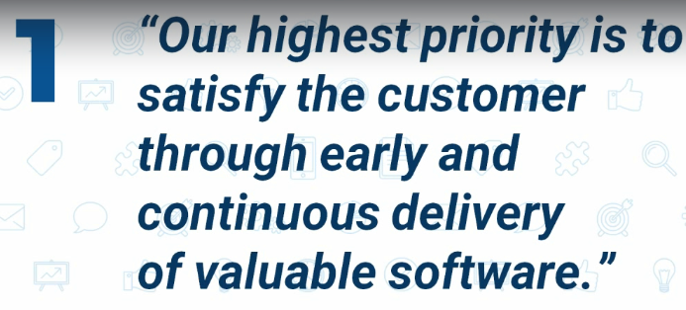

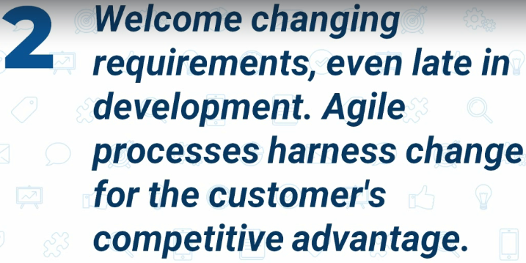

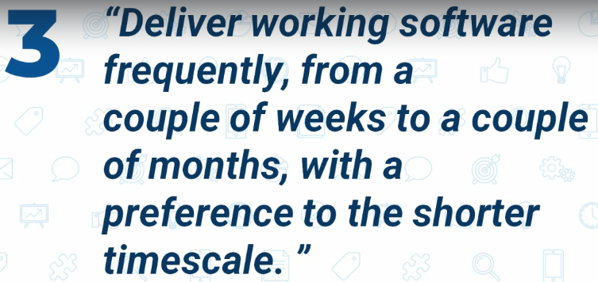

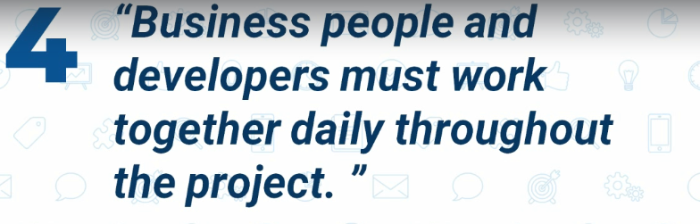

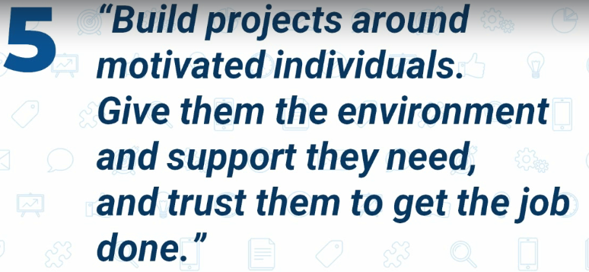

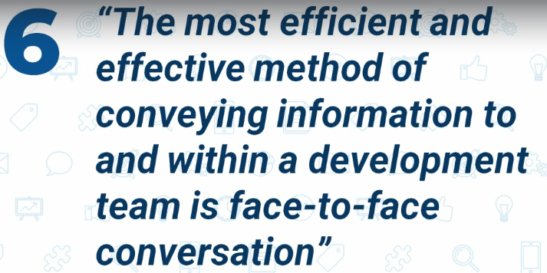



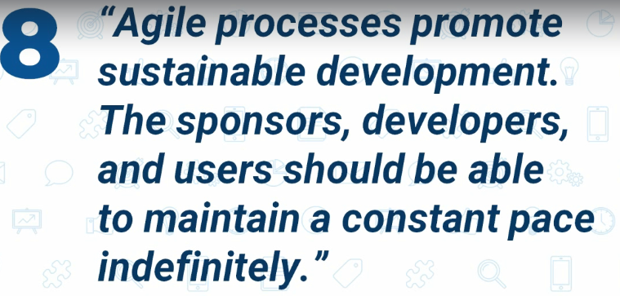

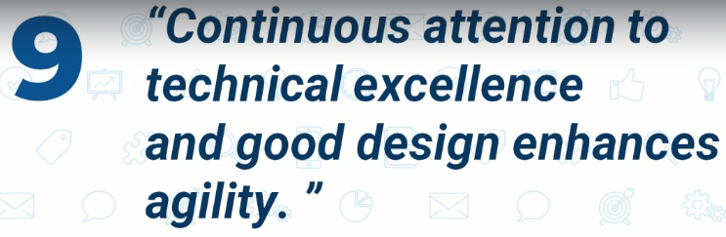

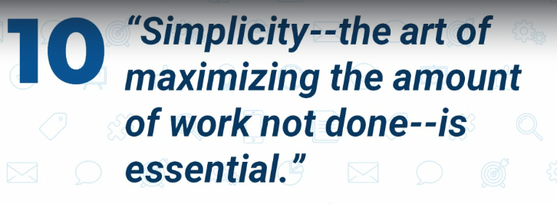

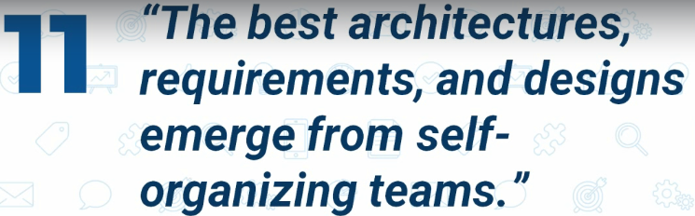

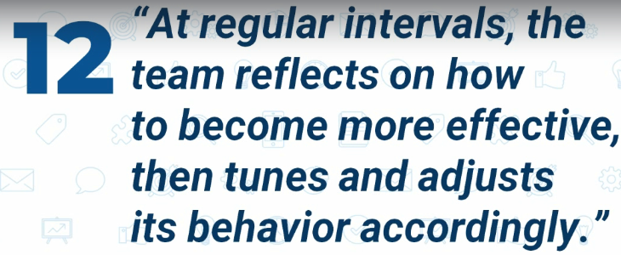

SCRUM/Sprint:

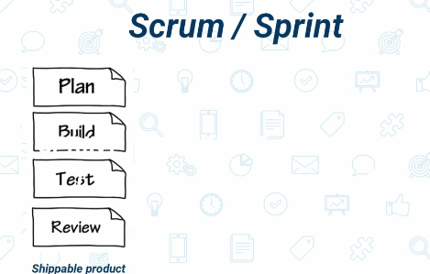

Break the entire application into multiple units then take each unit as a part of one sprint build tes and give to the client for the feed back.

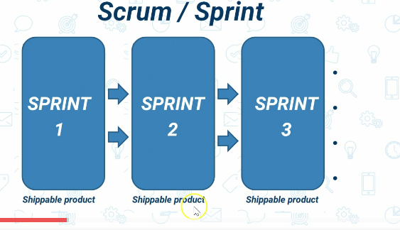

Software is developed as incremental and iterative model

Sprint artifacts:

1. Product backlog: all requirement associated with the system to build.
2. Sprint backlog: List of the items to be completed in the sprint.
3. Burn down chart: activity to track how good the sprint is executed.

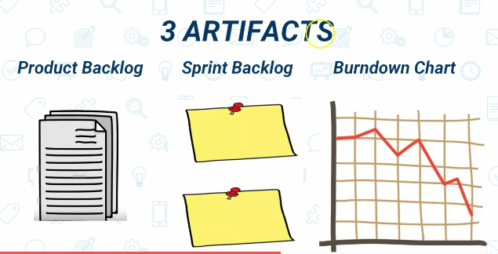

3Roles:

Product owner: responsible person from the company to understand the client requirement and communicate that to the team

Scrum master: person handel scrum meeting

Team: developer, tester, design team etc.

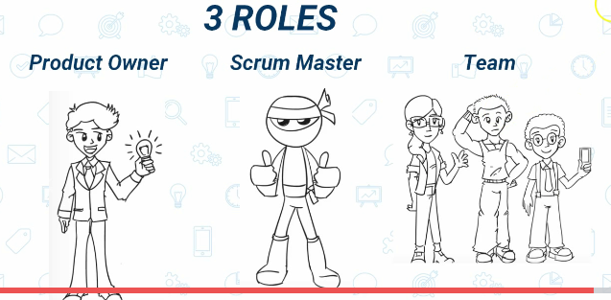

3Ceremonies:

1. Sprint planning:

Decide what to be done on the sprint

1. Scrum meeting:

team, client, product owner, scrum master

1. Sprint review: (demo retrospective)

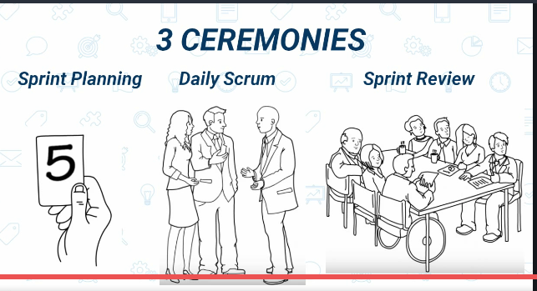

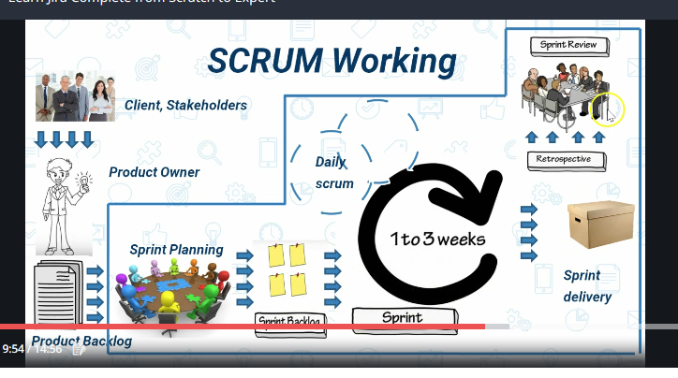

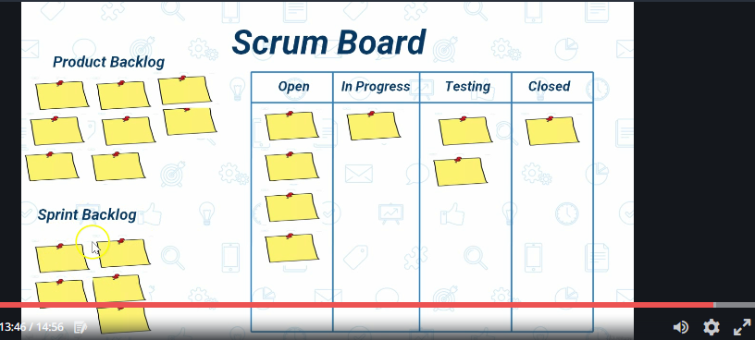

Components of jira

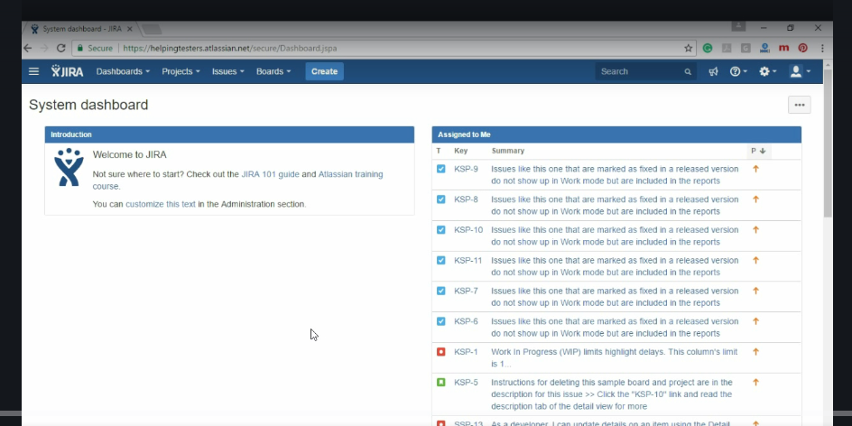

Epic: major implementation in application

Story: use cases to be consider after the functionality is developed(give, when, then).

Task: functionality to be implemented

Work flow is a backbone of the jira

Watch list:

List of all ppl to get notification of the item

Story point:

Pointing the issues based on the complexity of the task.

Eg building site with 2 page home and contact each will be called as epic